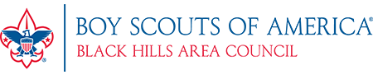

Blitz Challenge
August 21st -September 10th

Sell $750, $1,000, or $1,250 of popcorn in this time and earn:

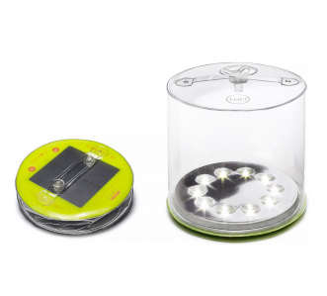
$750 Prize $1,000 Prize $1,250 Prize (Pick 1)
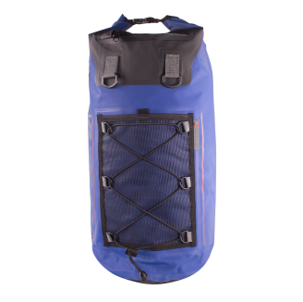
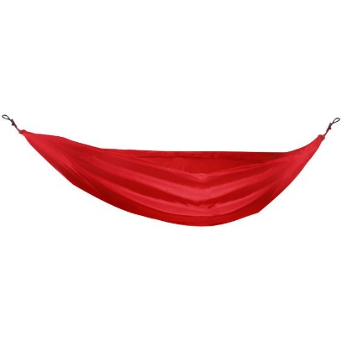

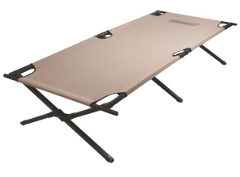
*Parents*
Please make a copy of this form for your records. Submit one complete form per Scout, with a copy of the popcorn order form and app sales to corey.davis@scouting.org or drop off at the Council Office, 144 North St, Rapid City, SD 57701 by Thursday, Sept. 10th at 5pm. Late orders will not be accepted. Prizes will be distributed to units.
Pack #____________ Troop #_____________ Crew #______________ Post # _____________
Scouts Name__________________________________________________________________
Parent Name__________________________________________________________________
Address______________________________________________________________________
Contact Number________________________ Sale Value_____________(Please attach Forms)
Email________________________________________________________________________
Prize Choice (Circle) Solar Lantern BSA Hammock Waterproof Backpack or Cot
Blitz Challenge prizes are for Scouts who sell at least $750, $1,000, or $1,250 worth of popcorn product by Sept 10th, 2020. This includes online sales this year.

